VPC USING TERRAFORM

**Terraform:**

Terraform is an open-source infrastructure as code (IaC) tool developed by HashiCorp. It allows users to define and provision infrastructure resources, such as virtual machines, networks, and storage, across multiple cloud providers and on-premises data centers using a declarative language.

With Terraform, infrastructure is defined in configuration files using a domain-specific language (DSL) called HashiCorp Configuration Language (HCL). Terraform can interpret these configuration files and apply changes to the infrastructure resources in a safe and predictable way, enabling users to manage and scale their infrastructure more efficiently.

Terraform is designed to be cloud-agnostic, which means it can be used with multiple cloud providers such as Amazon Web Services (AWS), Microsoft Azure, Google Cloud Platform (GCP), and more. Additionally, Terraform supports modular design, enabling users to break down large configurations into smaller, reusable modules that can be shared and maintained more easily.

Overall, Terraform is a powerful tool for managing infrastructure resources in a consistent, repeatable, and automated way, making it a popular choice for DevOps teams and infrastructure engineers.

* **Step by step process to create VPC and EC2 using Terraform**

**\*Download the AWS CLI using the below commands**.

Download and run the AWS CLI MSI installer for Windows (64-bit):

<https://awscli.amazonaws.com/AWSCLIV2.msi>

Alternatively, you can run the msiexec command to run the MSI installer.

C:\> **msiexec.exe /i** [**https://awscli.amazonaws.com/AWSCLIV2.msi**](https://awscli.amazonaws.com/AWSCLIV2.msi)

C:\> **msiexec.exe /i https://awscli.amazonaws.com/AWSCLIV2.msi */qn***

To confirm the installation, open the **Start** menu, search for cmd to open a command prompt window, and at the command prompt use the aws --version command.

C:\> **aws –version**

**\*Download the Terraform**

[**https://developer.hashicorp.com/terraform/downloads**](https://developer.hashicorp.com/terraform/downloads)

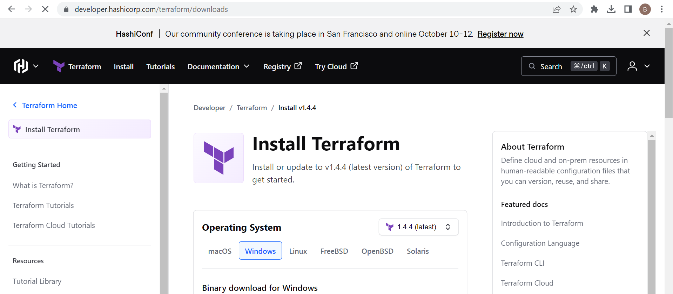

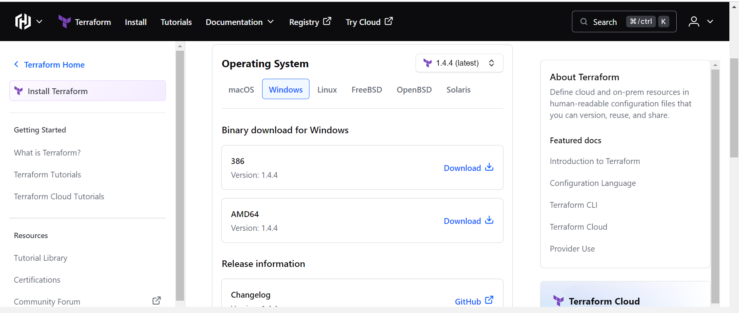

**Download AMD64**

**\*Create a IAM user in AWS management console.**

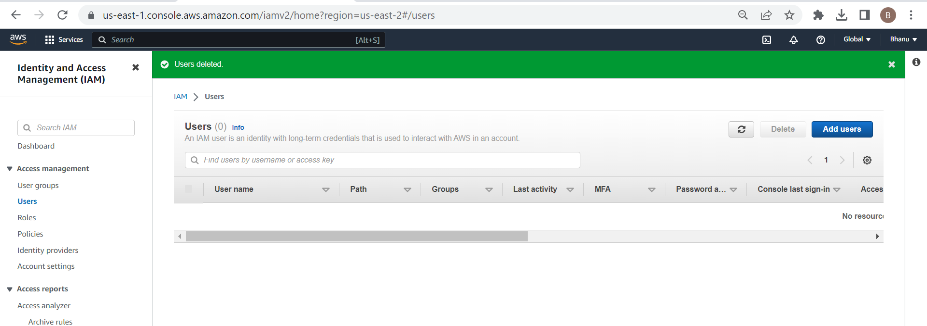

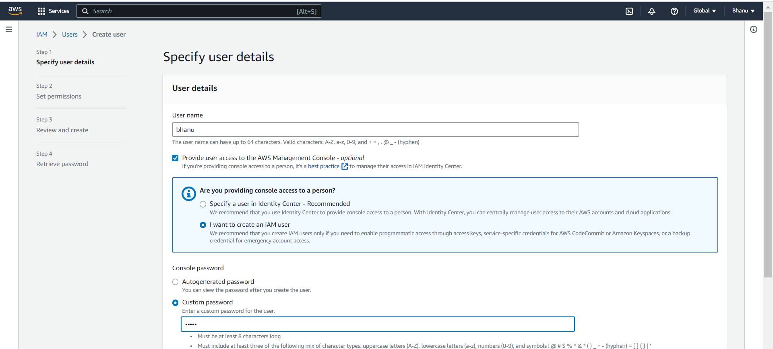

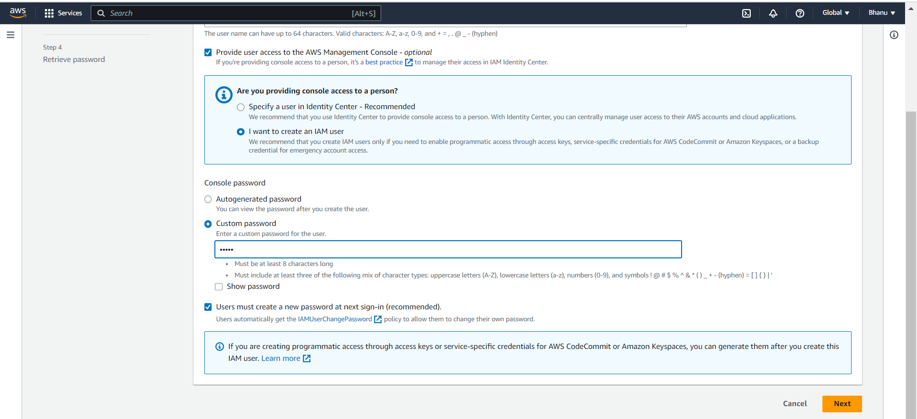

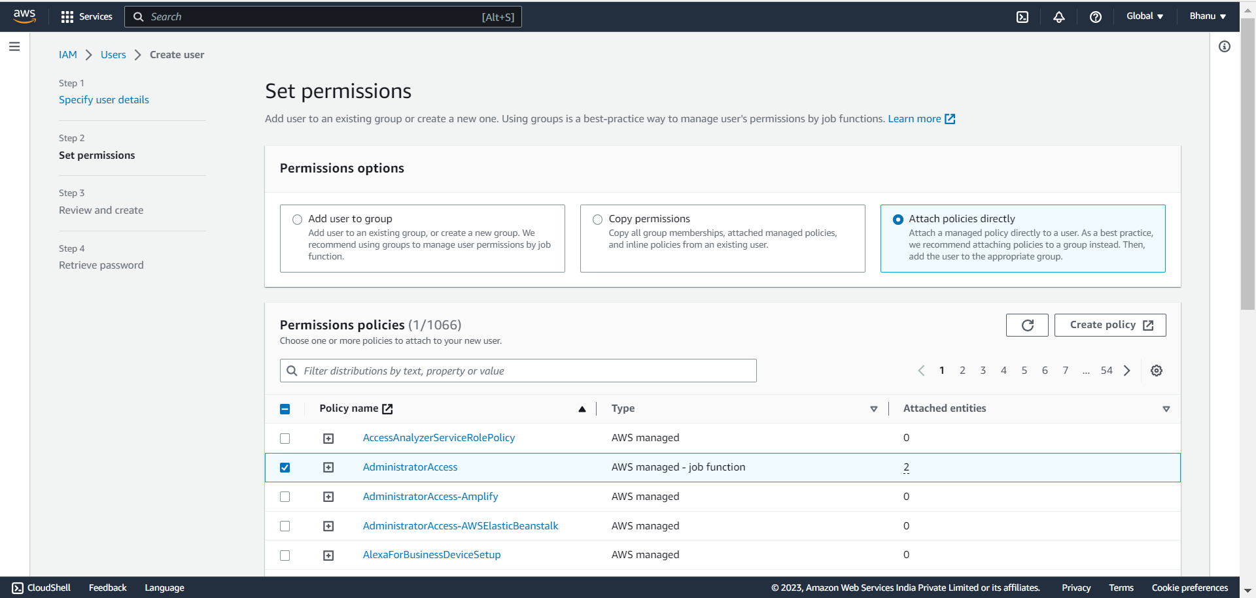

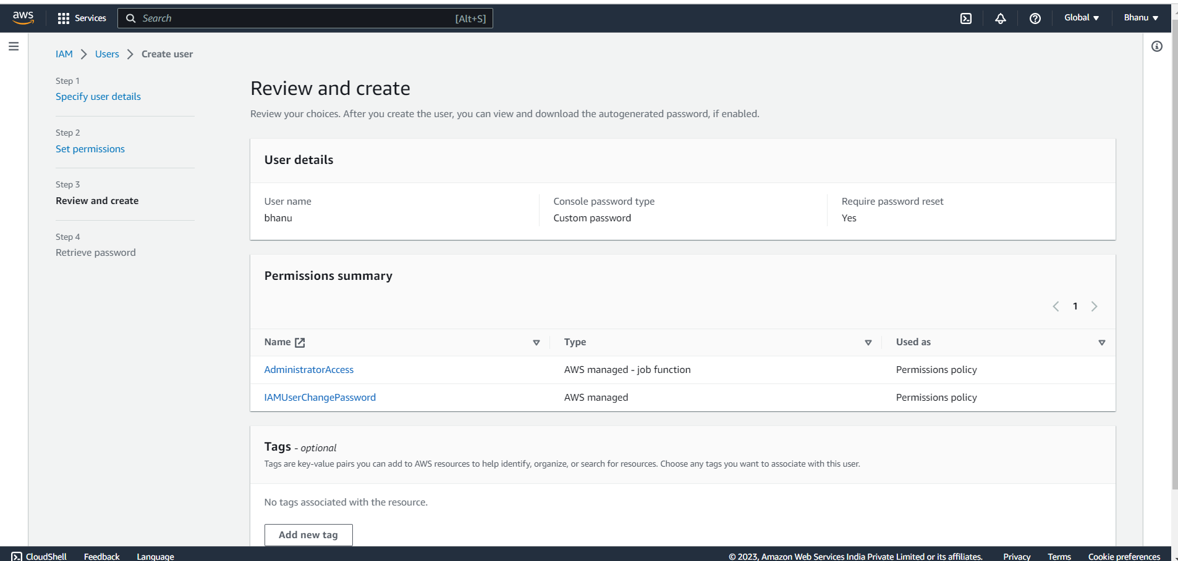

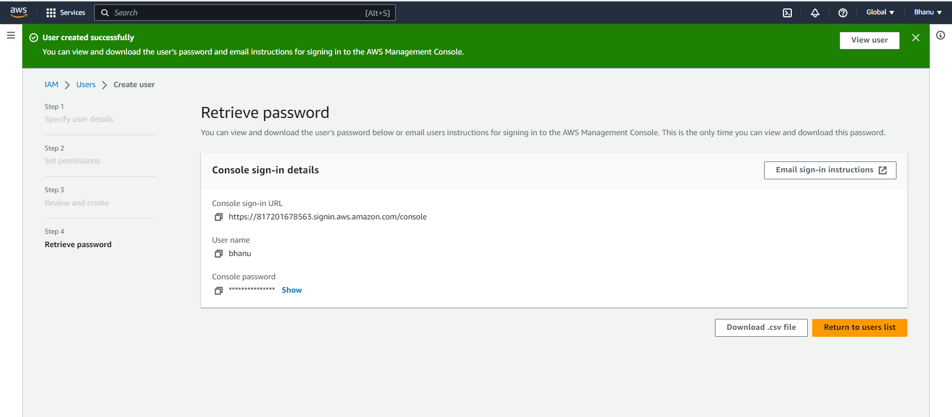

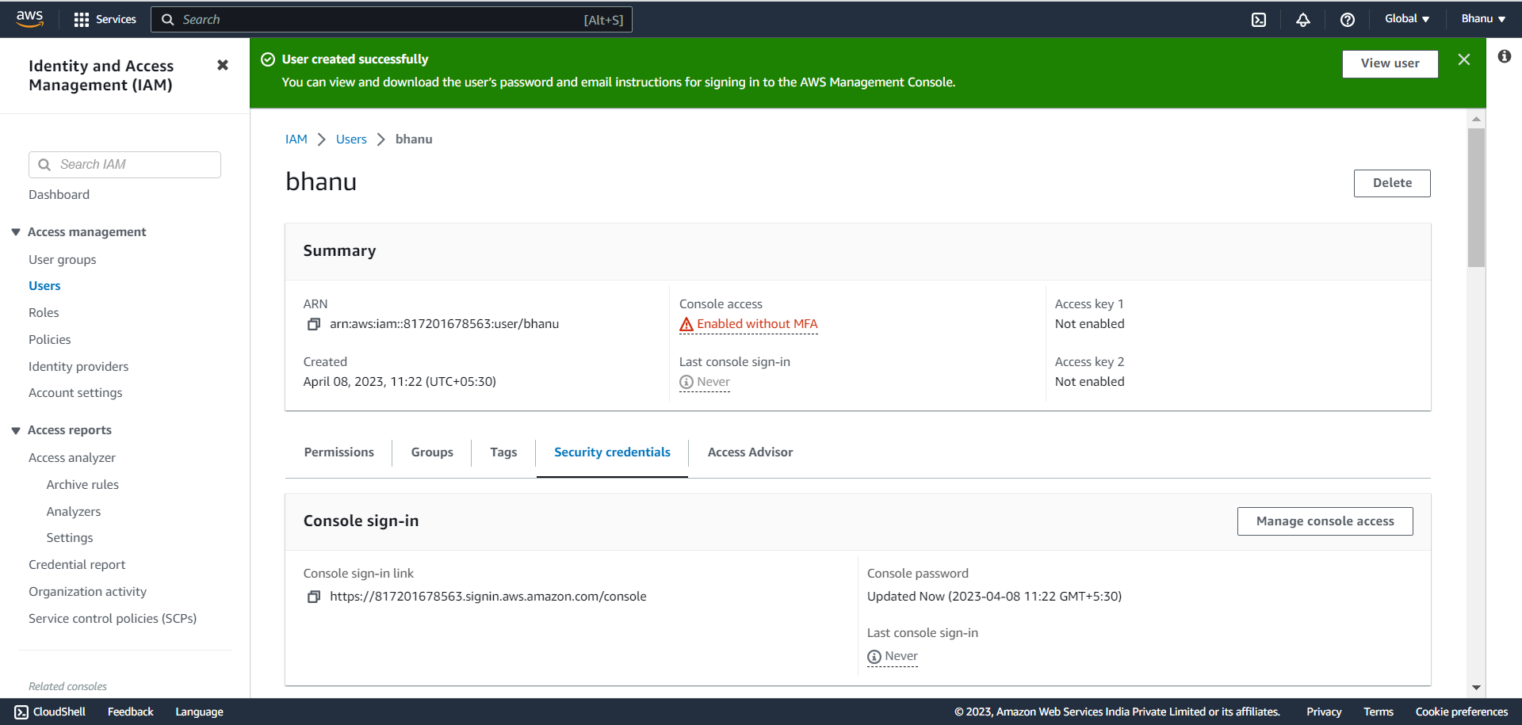

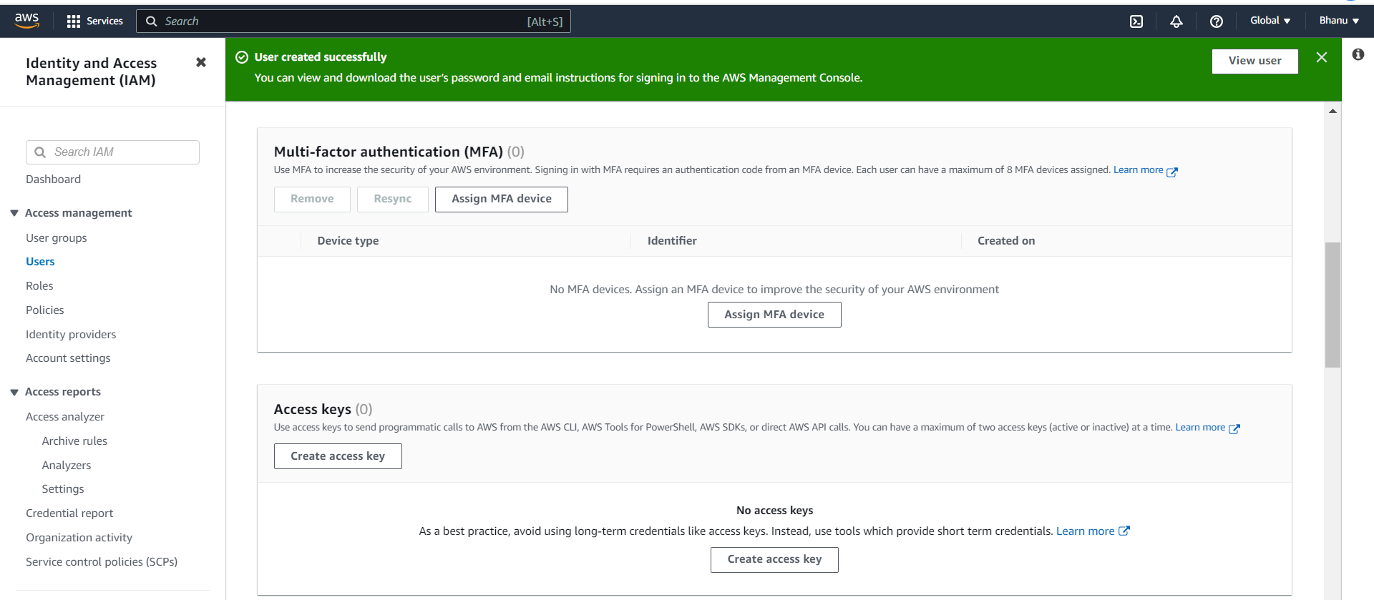

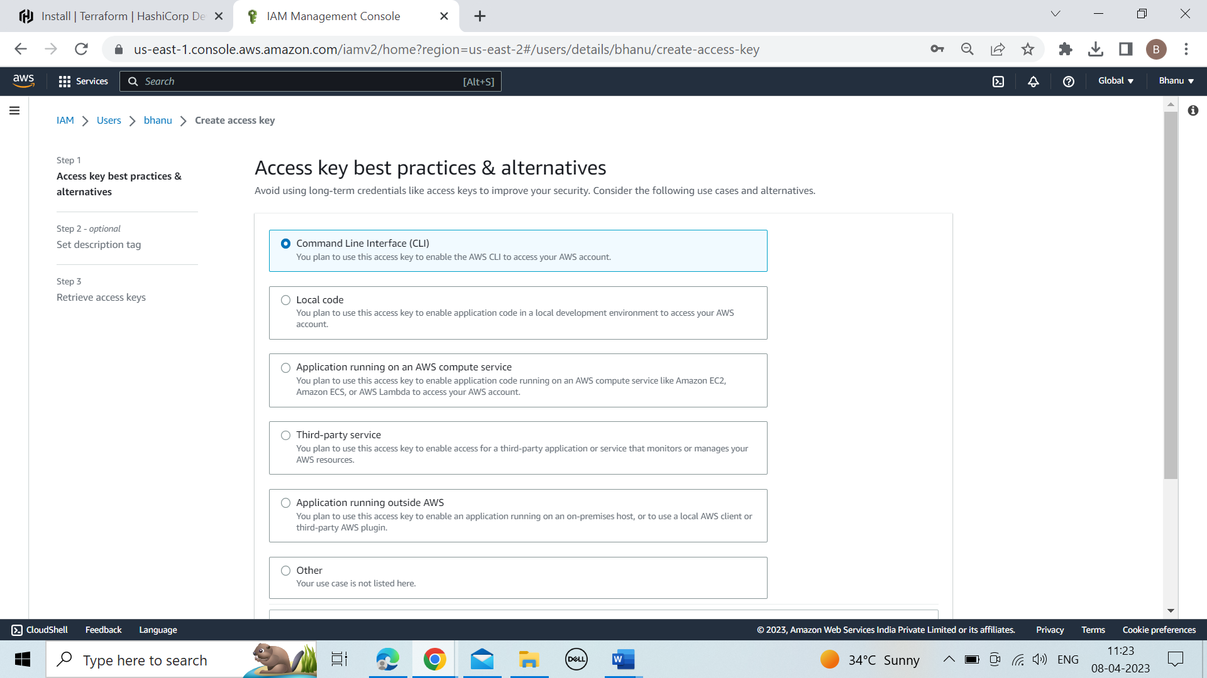

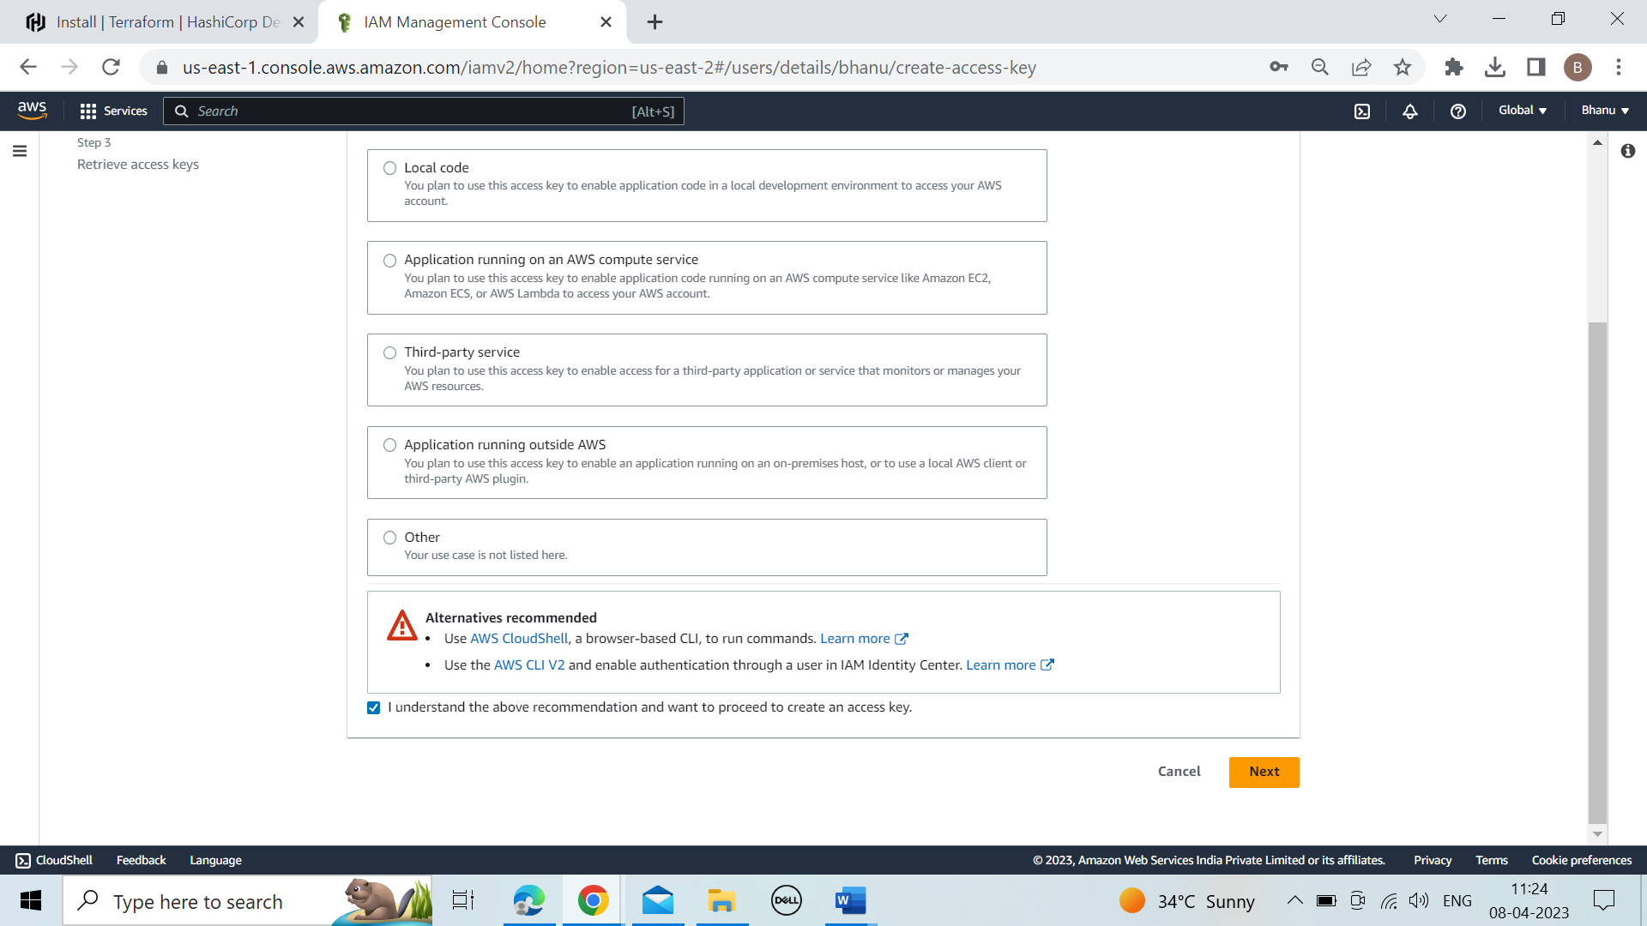

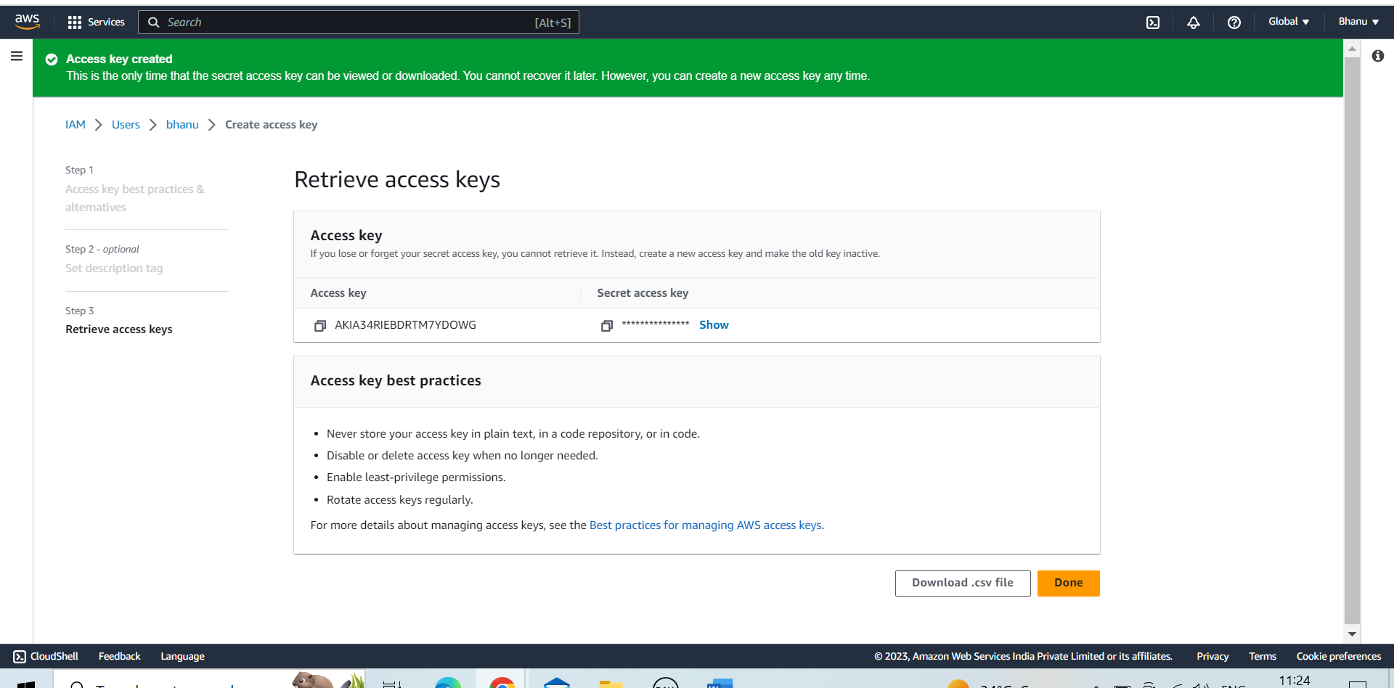

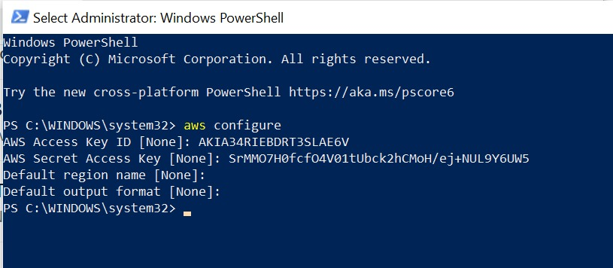

**\*Go to downloads**

**\*Create a folder**

**\*Open the VS code**

**\*Create a file with .tf extension**

**Copy the below code**

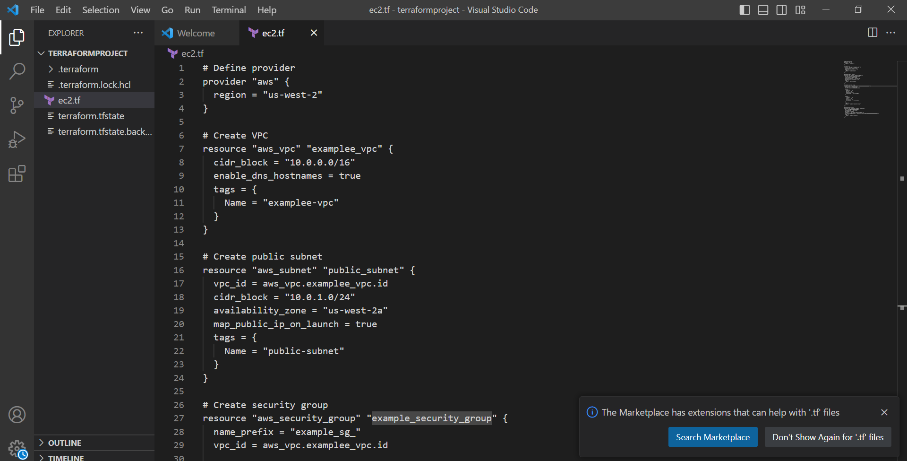

**# Define provider**

**provider "aws" {**

**region = "us-west-2"**

**}**

**# Create VPC**

**resource "aws_vpc" "examplee_vpc" {**

**cidr_block = "10.0.0.0/16"**

**enable_dns_hostnames = true**

**tags = {**

**Name = "examplee-vpc"**

**}**

**}**

**# Create public subnet**

**resource "aws_subnet" "public_subnet" {**

**vpc_id = aws_vpc.examplee_vpc.id**

**cidr_block = "10.0.1.0/24"**

**availability_zone = "us-west-2a"**

**map_public_ip_on_launch = true**

**tags = {**

**Name = "public-subnet"**

**}**

**}**

**# Create security group**

**resource "aws_security_group" "example_security_group" {**

**name_prefix = "example_sg_"**

**vpc_id = aws_vpc.examplee_vpc.id**

**ingress {**

**from_port = 22**

**to_port = 22**

**protocol = "tcp"**

**cidr_blocks = ["0.0.0.0/0"]**

**}**

**ingress {**

**from_port = 80**

**to_port = 80**

**protocol = "tcp"**

**cidr_blocks = ["0.0.0.0/0"]**

**}**

**tags = {**

**Name = "example-security-group"**

**}**

**}**

**# Create EC2 instance**

**resource "aws_instance" "example_instance" {**

**ami = "ami-0c252bb9e6b71848e"**

**instance_type = "t2.micro"**

**key_name = "my-key"**

**subnet_id = aws_subnet.public_subnet.id**

**vpc_security_group_ids = [aws_security_group.example_security_group.id]**

**tags = {**

**Name = "example-instance"**

**}**

**}**

**\*Save the code**

**\*terraform init**

**\*terraform plan**

**\*terraform apply**

🡪Now open the aws management console and you can see that the VPC,subnet,Ec2 are created.